Phone: 0821-2548285 to 2548289, Fax: (091) 821-2548290
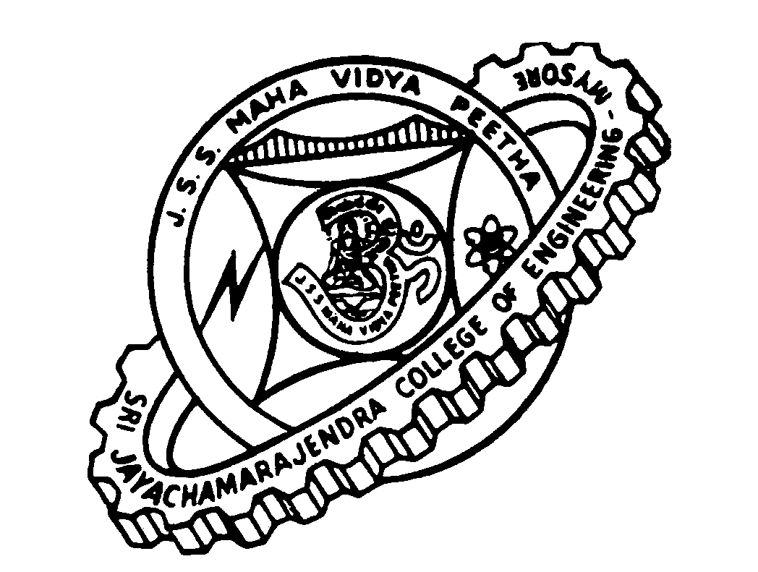
Sri Jayachamarajendra College of Engineering Mysuru, Karnataka (INDIA)
Department of Electronics and Communication

7th February 2017
Letter of Recommendation

Mr.Abhay M S Aradhya is a sincere, hardworking meritorious student who is remembered for his pleasing personality by both faculty and students of Electronics Engineering department, Sri Jayachamrajendra College of Engineering (SJCE), Mysuru, India. I have observed Mr.Abhay both as a teaching faculty and the Head Of the Dept. Electronics and Communication, SJCE and was greatly impressed with his genuine academic interest, innovative skills that were evident in the various project works undertaken by him during his studentship of bachelor of engineering degree.
His project proposal on “piezo-electric sensors and signal measurement” was selected by NAL, Bengaluru, one of the prestigious research laboratories in India and provided necessary lab facilities to work. He has successfully completed the project work in a record time with significant finding and meaningful conclusion.
His research concept on development of “Robo-stainer” attracted celebrated Karnataka State Government meritorious research funding, which was successfully accomplished not only within time, but a working model was delivered which received profuse acclamation both from funding agency and electronic engineer professionals. The novelty in development of ‘Robo-stainer’, its commercial viability was found to be worth patenting. Thus, the process of patenting “Robostainer” is in progress. I believe this is a rare accomplishment of an undergraduate student.
Development of “Automated Body Mass Index Indicator” instrument is a standing testimony for Mr.Abhay’s inherent capacity for original conceptualization, methodical planning and execution of the work. This project was conceptualized by him during his early days at college and led a team to develop a prototype. Further, he successfully advanced this to a commercial model which was rigorously field tested with a 4000 subjects. The instrument is ready for commercial exploitation.
Mr.Abhay endowed with intrinsic nature of management of multidisciplinary task and his perseverance, interest and hard work has resulted in a research publication entitled “Feature Isolation and Extraction Of Satellite Images For Remote Sensing Applications” in a peer reviewed journal viz International Journal of Electronics and Communication Engineering and Technology (IJECET).
His work entitled “Pressure Actuated Suspension System” was also presented in “Partners for the advancement of Collaborative Engineering Education (PACE) - 2014” an international conference held at Turin, Italy, which is worth laudable.
Mr. Abhay’s academic excellence, crowned with patent and research publication in peer reviewed international journal has held him high above his contemporaries. He deserves all the encouragement and opportunity to pursue his academic endeavors. I strongly recommend Mr.Abhay to Master Degree program in your esteem University with research/teaching assistantship. I truly believe that he will be an asset to the institution.

Thanking you,

(Dr.M.N.Shanmukha Swamy)

